|  |  |  |  |  |  |
| --- | --- | --- | --- | --- | --- |
| Description | Current | Change | Recommended | Allocation | ICR |
| BT Panorama Super | | | | | |
| Investment number one | $0 | $33,000 | $33,000 | 33.00% | 1.50% |
| Investment number three | $0 | $7,000 | $7,000 | 7.00% | 4.50% |
| Investment number four | $0 | $60,000 | $60,000 | 60.00% | 0.00% |
| BT Panorama Super | $0 | $100,000 | $100,000 |  |  |
| Total | $0 | $100,000 | $100,000 |  |  |

|  |  |  |  |  |  |
| --- | --- | --- | --- | --- | --- |
| Description | Current | Change | Recommended | Allocation | ICR |

|  |  |  |  |  |  |
| --- | --- | --- | --- | --- | --- |
| Description | Current | Change | Recommended | Allocation | ICR |
| BT Wrap | | | | | |
| Investment number one | $134,000 | -$101,000 | $33,000 | 32.89% | 1.50% |
| Investment number three | $0 | $7,000 | $7,000 | 6.98% | 4.50% |
| Investment number four | $333 | $59,667 | $60,000 | 59.80% | 0.00% |
| INVESTMENT 8 - MANAGED ACC | $0 | $333 | $333 | 0.33% | 0.00% |
| Investment number two | $20,000 | -$20,000 | $0 | 0.00% | 0.00% |
| Investment number one | $101,000 | -$101,000 | $0 | 0.00% | 1.20% |
| Investment number one | $777 | -$777 | $0 | 0.00% | 1.50% |
| BT Wrap | $256,110 | -$155,777 | $100,333 |  |  |
| MyNorth Super | | | | | |
| Investment number one | $0 | $25,000 | $25,000 | 38.46% | 1.50% |
| Investment number one | $0 | $10,000 | $10,000 | 15.38% | 1.50% |
| Investment number two | $0 | $30,000 | $30,000 | 46.15% | 0.00% |
| MyNorth Super | $0 | $65,000 | $65,000 |  |  |
| Total | $256,110 | -$90,777 | $165,333 |  |  |

|  |  |  |
| --- | --- | --- |
| Status | Current | Recommended |
| Description | BT Wrap | BT Panorama Super |
| Balance | $122,165 | $100,000 |
| One-off Fees Subheader |  |  |
| Ongoing Fees Subheader | | |
| - Admin Fee (Flat) | $54.00 | $480.00 |
| - Admin Fee (Floating) | $610.82 (0.50%) | $500.00 (0.50%) |
| Subtotal | $664.82 | $980.00 |
| Adviser Fee (Flat) | $0.00 | None |
| Total | $664.82 (0.54%) | $980.00 (0.98%) |
| Comparative Total | $664.82 | $980.00 |

|  |  |
| --- | --- |
| Status | Alternative |
| Description | BT Panorama Super |
| Balance | $47,777 |
| One-off Fees Subheader |  |
| Ongoing Fees Subheader | |
| - Sliding Admin Fee | $71.67 (0.15%) |
| - Admin Fee (Flat) | $480.00 |
| Subtotal | $71.67 |
| Adviser Fee (Flat) | None |
| Total | $71.67 (0.15%) |
| Comparative Total | $0.00 |

|  |  |  |  |  |
| --- | --- | --- | --- | --- |
| Status | Recommended | Recommended | Alternative | Alternative |
| Description | BT Wrap | MyNorth Super | BT Wrap | MyNorth Super |
| Balance | $100,333 | $65,000 | $78,000 | $65,000 |
| One-off Fees Subheader |  |  |  |  |
| Buy/Sell Fees | $120.00 (0.12%) | $0.00 (0.00%) | $0.00 (0.00%) | $0.00 (0.00%) |
| One-off Subtotal | $120.00 | $0.00 | $0.00 | $0.00 |
| Ongoing Fees Subheader | | | | |
| - Admin Fee (Flat) | $0.00 | $500.00 | $0.00 | $500.00 |
| - Admin Fee (Floating) | $501.66 (0.50%) | $0.00 (0.00%) | $390.00 (0.50%) | $0.00 (0.00%) |
| Subtotal | $501.66 | $500.00 | $390.00 | $500.00 |
| Adviser Fee (Flat) | None | None | None | None |
| Total | $501.66 (0.50%) | $500.00 (0.77%) | $390.00 (0.50%) | $500.00 (0.77%) |
| Comparative Total | $0.00 | | $1,001.66 | |

|  |  |  |
| --- | --- | --- |
| - Consol Balance | $265,333 | $265,333 |
| Adviser Fee (Flat) | $0.00 | None |

|  |  |
| --- | --- |
| - Consol Balance | $265,333 |
| Adviser Fee (Flat) | None |

|  |  |  |  |  |
| --- | --- | --- | --- | --- |
| - Consol Balance | $265,333 | $265,333 | $265,333 | $265,333 |
| Adviser Fee (Flat) | None | None | None | None |

|  |  |  |  |
| --- | --- | --- | --- |
| Status | Current | Risk Profile | Variance |
| Defensive | | | |
| Cash | 3.27% | 0.00% | 3.27% |
| Australian Fixed Interest | 0.13% | 49.00% | -48.87% |
| International Fixed Interest | 0.13% | 0% | 0.13% |
| Subtotal | 3.54% | 49.00% | -45.46% |
| Growth Subheader | | | |
| Australian Equities | 54.78% | 51.00% | 3.78% |
| International Equities | 41.68% | 1.00% | 40.68% |
| Australian Listed Property | 0% | 0% | 0% |
| International Listed Property | 0% | 0% | 0% |
| Direct Property | 0% | 0% | 0% |
| Growth Subtotal | 96.46% | 52.00% | 44.46% |
| Alternative Subheader | | | |
| Alternatives | 0% | 0% | 0% |
| Alternative Subtotal | 0% | 0% | 0% |
| Total | 100.00% | 100.00% | 100.00% |

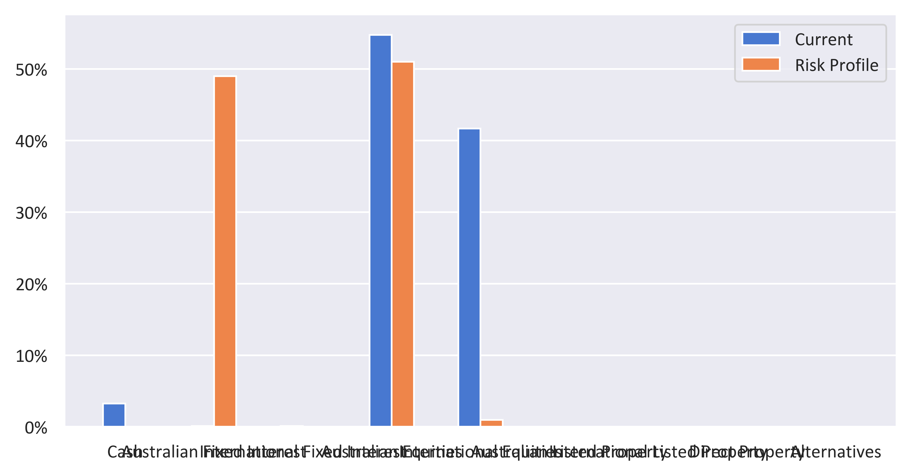

|  |  |  |  |
| --- | --- | --- | --- |
| Status | Recommended | Risk Profile | Variance |
| Defensive | | | |
| Cash | 7.54% | 0.00% | 7.54% |
| Australian Fixed Interest | 22.39% | 49.00% | -26.61% |
| International Fixed Interest | 22.39% | 0% | 22.39% |
| Subtotal | 52.31% | 49.00% | 3.31% |
| Growth Subheader | | | |
| Australian Equities | 28.08% | 51.00% | -22.92% |
| International Equities | 19.48% | 1.00% | 18.48% |
| Australian Listed Property | 0% | 0% | 0% |
| International Listed Property | 0% | 0% | 0% |
| Direct Property | 0% | 0% | 0% |
| Growth Subtotal | 47.56% | 52.00% | -4.44% |
| Alternative Subheader | | | |
| Alternatives | 0% | 0% | 0% |
| Alternative Subtotal | 0% | 0% | 0% |
| Total | 100.00% | 100.00% | 100.00% |

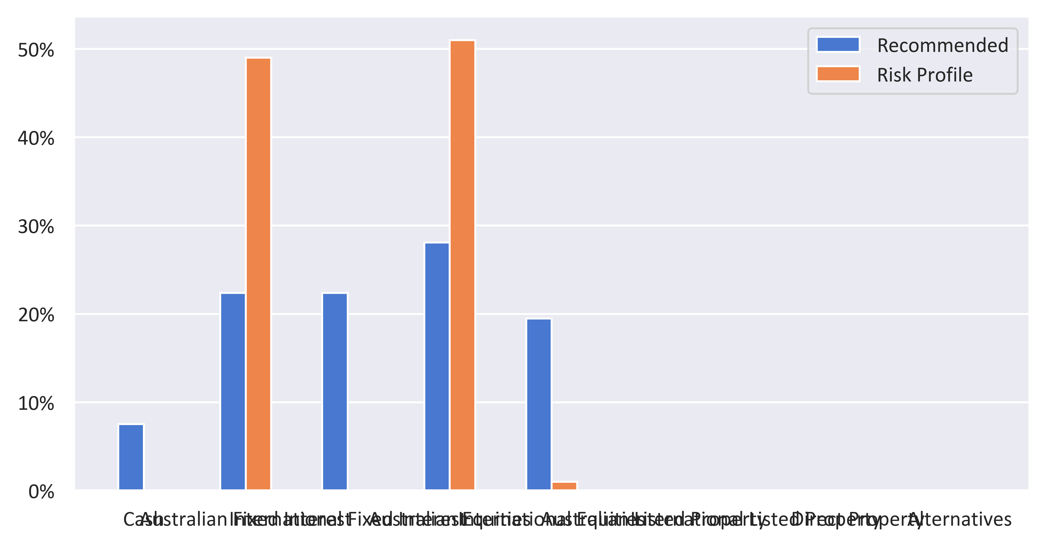

|  |  |  |  |  |
| --- | --- | --- | --- | --- |
| Status | Current | Risk Profile | Recommended | Variance |
| Defensive | | | | |
| Cash | 3.27% | 0.00% | 7.54% | 7.54% |
| Australian Fixed Interest | 0.13% | 49.00% | 22.39% | -26.61% |
| International Fixed Interest | 0.13% | 0% | 22.39% | 22.39% |
| Subtotal | 3.54% | 49.00% | 52.31% | 3.31% |
| Growth Subheader | | | | |
| Australian Equities | 54.78% | 51.00% | 28.08% | -22.92% |
| International Equities | 41.68% | 1.00% | 19.48% | 18.48% |
| Australian Listed Property | 0% | 0% | 0% | 0% |
| International Listed Property | 0% | 0% | 0% | 0% |
| Direct Property | 0% | 0% | 0% | 0% |
| Growth Subtotal | 96.46% | 52.00% | 47.56% | -4.44% |
| Alternative Subheader | | | | |
| Alternatives | 0% | 0% | 0% | 0% |
| Alternative Subtotal | 0% | 0% | 0% | 0% |
| Total | 100.00% | 100.00% | 100.00% | 0.00% |

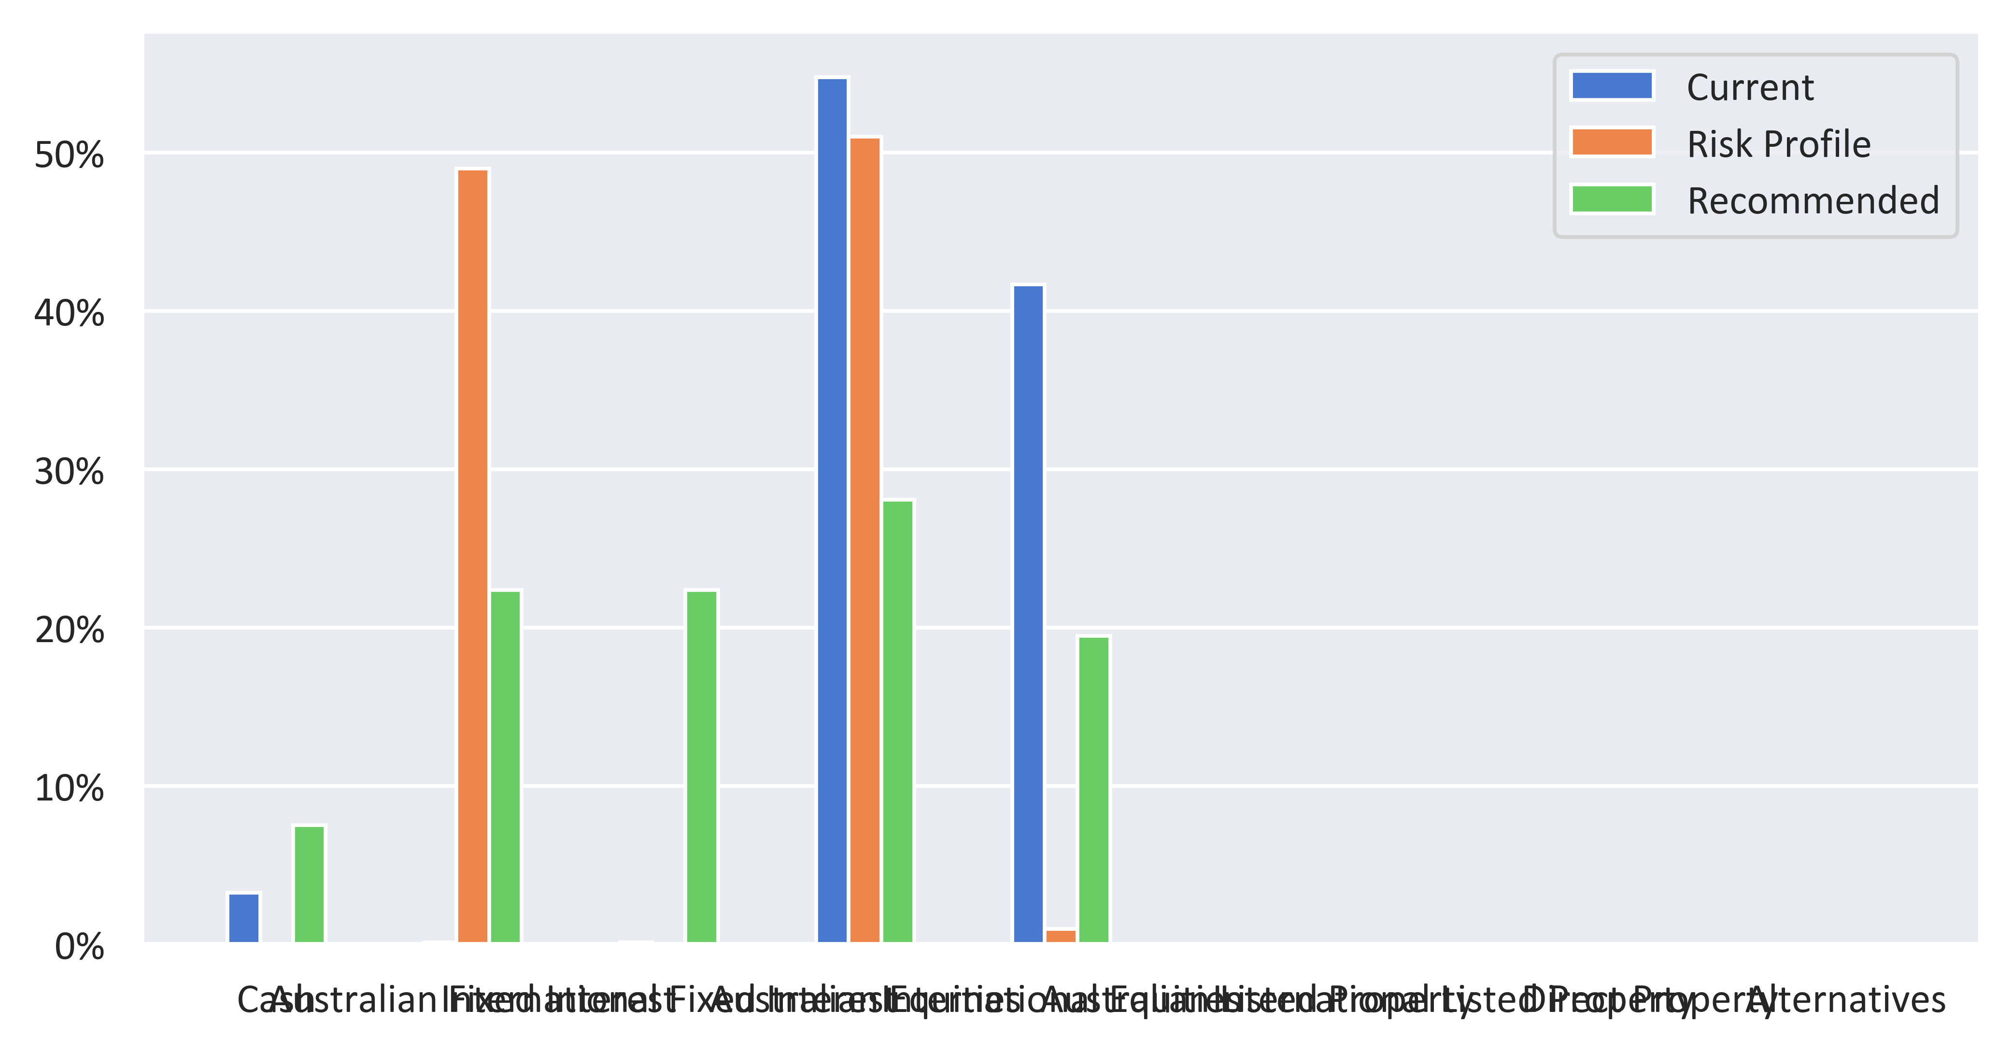

|  |  |  |  |
| --- | --- | --- | --- |
| Status | Current | Recommended | Variance |
| Defensive | | | |
| Cash | 3.27% | 7.54% | 4.26% |
| Australian Fixed Interest | 0.13% | 22.39% | 22.25% |
| International Fixed Interest | 0.13% | 22.39% | 22.25% |
| Subtotal | 3.54% | 52.31% | 48.77% |
| Growth Subheader | | | |
| Australian Equities | 54.78% | 28.08% | -26.70% |
| International Equities | 41.68% | 19.48% | -22.20% |
| Australian Listed Property | 0% | 0% | 0% |
| International Listed Property | 0% | 0% | 0% |
| Direct Property | 0% | 0% | 0% |
| Growth Subtotal | 96.46% | 47.56% | -48.89% |
| Alternative Subheader | | | |
| Alternatives | 0% | 0% | 0% |
| Alternative Subtotal | 0% | 0% | 0% |
| Total | 100.00% | 100.00% | 100.00% |

